**AWS Task-2**

**Task Description:**

Set up a VPC with an Internet gateway, create a public subnet with 256 IP addresses, a private subnet with 256 IP addresses, make a route table connecting the Internet gateway and the subnets, and launch a Linux EC2 instance by using the above VPC and public subnet.

1. Create a vpc  
   2. create a public and private subnet for different Availability zone by assigning  
   CIDR blocks.  
   3. Create Internet Gateway and attach it to the Vpc.  
   4. Create two Routing Table one as Public and one as private by associating the appropriate subnets to it.  
   5. Edit the Public route Table's Route alone and map the Internet Gateway, not the Private one and leave it as it is.  
   6. Create two security groups- one for public and one for private then edit the public security group's inbound rules with RDP, HTTP, HTTPS, SSH and map 0.0.0.0/0 in the source, And then for private security group edit the inbound rules and map the Security group of public in the source.  
   7. Create two Ec2's one in public and one in private subnets with proper security  
   groups .  
   8. Login into the public Ec2 instance and check whether it is getting internet connection.  
   9. Create NAT gateway with new elastic IP for the internet connection in the private subnet. then Map it to Private Routing table  
   10. Now login to the private ec2 and verify the connectivity and internet facility.  
   Sent from my iPhone

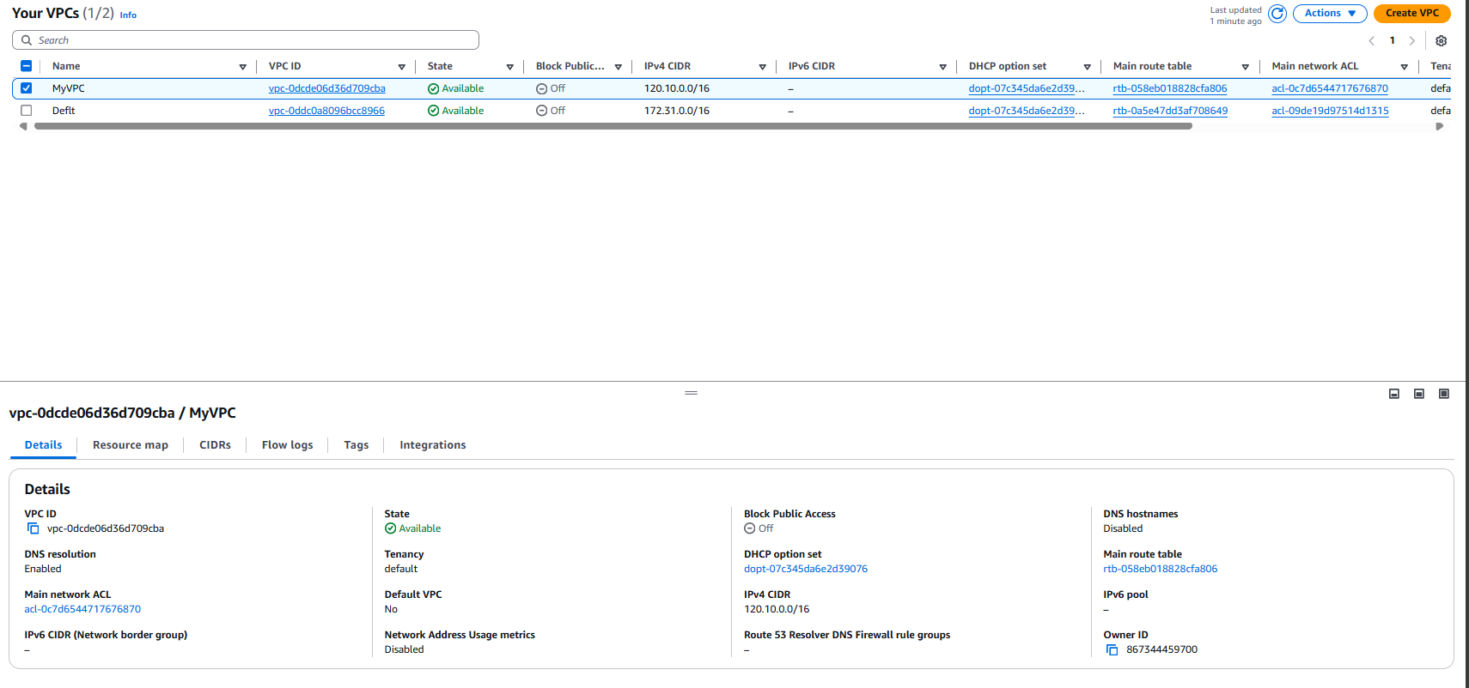

**SUBNETS**



**Route-table**

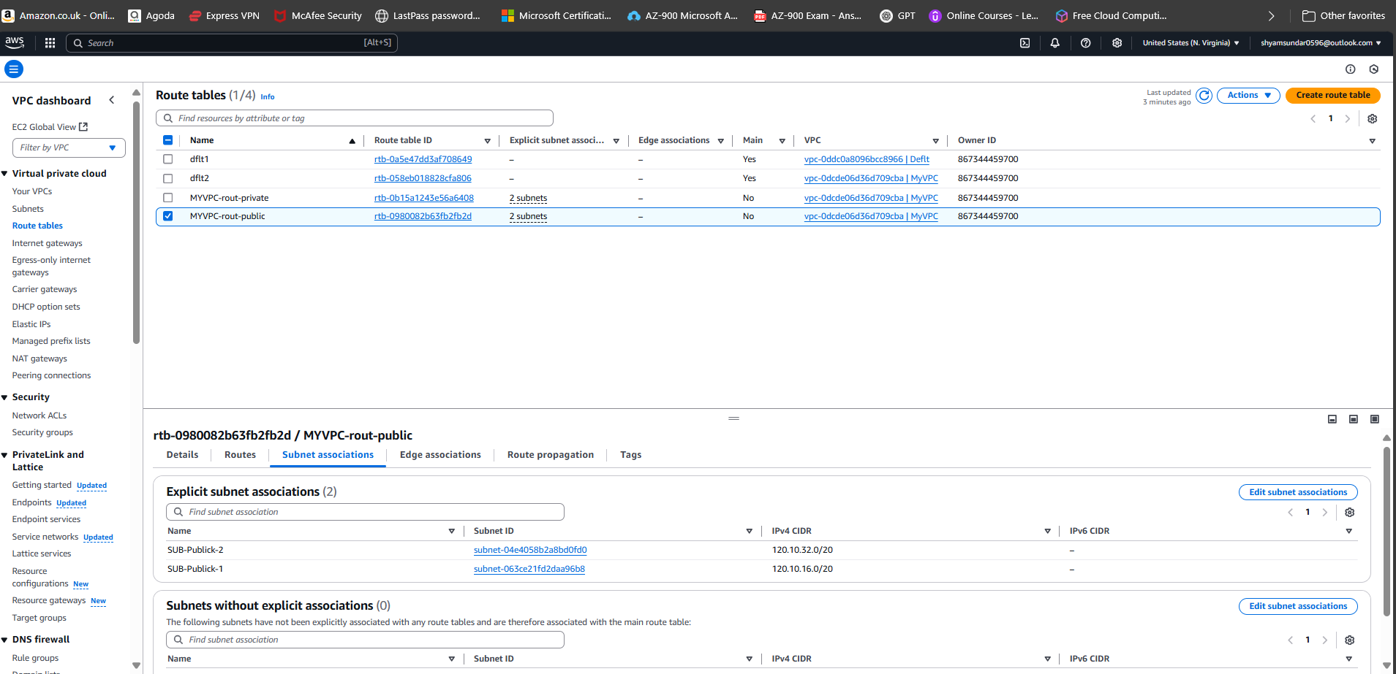

**Internet-gateway**

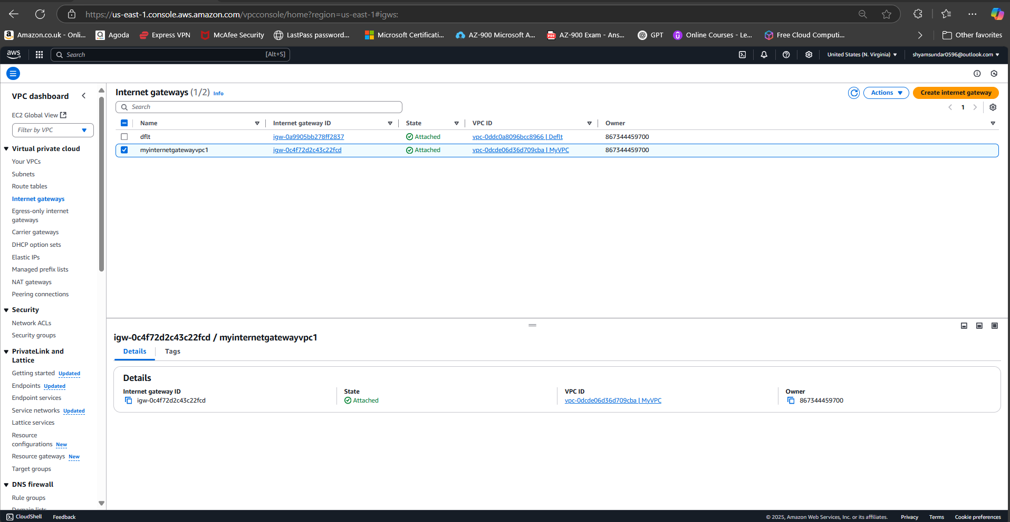

**Security-Group**

